Hunar Saaz
Policy, Research, and Institutional Advisory Platform

The Policy, Research, and Institutional Advisory Platform at HunarSaaz is a policy and advisory setup established to bridge the persistent gap between evidence, public decision-making, and implementation. We work at the intersection of research, evaluation, and institutional practice to support governments, development partners, and public institutions in designing solutions that are analytically rigorous, context-responsive, and operationally feasible. Our work is grounded in deep sectoral experience, methodological discipline, and a clear understanding that sustainable impact emerges not from ideas alone, but from their careful translation into systems that function on the ground.
Who We Are
We are a Pakistan-based policy, research, and institutional advisory platform working across the social sector. We operate through an integrated model that brings together policy analysis, applied research, programme design, monitoring and evaluation, and institutional strengthening within a single, coherent framework.
Our work is grounded in the belief that sustainable development outcomes depend not only on sound policies, but on the institutional capacity and systems required to translate policy intent into real-world results. Hunar Saaz engages with governments and development partners as a thinking institution-focused on coherence, practicality, and long-term institutional effectiveness rather than standalone interventions or fragmented technical inputs.

Why Policy, Research, and Institutional Advisory Platform at Hunar Saaz Exists
Across Pakistan’s social sector, the distance between policy intent and real-world outcomes remains persistently wide. Well-articulated policies, strategies, and frameworks are routinely developed, yet their translation into coherent programmes, effective delivery systems, and measurable results is often uneven. This gap is rarely due to a lack of effort or commitment. Instead, it reflects deeper structural and systemic weaknesses in how institutions plan, decide, and act.
One enduring challenge lies in the limited use of evidence for decision-making. Data, research, and monitoring outputs are frequently produced as compliance requirements rather than as tools for learning, course correction, and strategic choice. As a result, policies and programmes are often shaped by precedent, short-term pressures, or fragmented information rather than by context-sensitive analysis and robust evidence.
At the same time, social sector programming remains highly fragmented. Multiple actors operate in parallel, with overlapping mandates, disconnected interventions, and limited coordination across federal, provincial, and local levels. This fragmentation dilutes impact, places unnecessary burdens on implementing institutions, and weakens accountability for results.
These challenges are further compounded by institutional capacity gaps. Public sector entities and development partners alike face constraints in translating complex policy goals into implementable programme designs, adaptive delivery models, and decision-useful monitoring systems. Where capacity development efforts exist, they are often generic, episodic, and insufficiently embedded within core institutional processes.
Hunar Saaz was established in response to these realities. It exists to strengthen the link between policy intent, evidence generation, and practical implementation supporting institutions to move from well-meaning strategies to outcomes that are coherent, adaptive, and grounded in real-world conditions.

How We Think
Hunar Saaz approaches social sector work as a system challenge rather than a collection of isolated activities. Policies, programmes, institutions, incentives, and political realities interact in complex ways, and sustainable results emerge only when these elements are understood and addressed together.
Our work is evidence-informed, but never evidence for its own sake. We prioritize analysis that is decision-relevant, context-specific, and proportionate to institutional capacity. Research, data, and monitoring are treated as tools to improve choices and implementation pathways not as ends in themselves.
We place strong emphasis on contextual intelligence. Social, political, administrative, and fiscal realities shape what is feasible and what is not. Effective solutions must be designed with a clear understanding of these constraints, rather than assuming ideal conditions or linear implementation pathways.
We believe that good design precedes good delivery. Policies and programmes must be realistic, internally coherent, and aligned with institutional roles and incentives. Where design is weak, even well-resourced interventions struggle to achieve their intended outcomes.
Capacity, in our view, is built through practice rather than standalone training. Institutional strengthening is most effective when support is embedded within real work processes planning cycles, implementation decisions, monitoring routines, and review mechanisms allowing learning to occur through doing.
Finally, our work is guided by professional integrity and responsible engagement. We adhere to do-no-harm principles, remain attentive to power dynamics, and respect institutional ownership. Our role is not to substitute for institutions, but to work alongside them to strengthen their ability to deliver over time.

What We Do
Hunar Saaz provides integrated advisory, research, and institutional support services across the social sector. Our work is organized around interlinked service areas, reflecting the reality that policy, evidence, implementation, and capacity are inseparable in practice.
Policy, Strategy, and Systems Advisory
We support public sector institutions and development partners in translating policy priorities into coherent strategies and operational frameworks. This includes policy analysis, strategic planning, reform design, and support to align mandates, incentives, and delivery mechanisms across institutions and levels of government.
Research, Evidence, and Learning
Hunar Saaz undertakes applied research and analytical work designed to inform real decisions. We generate and synthesize evidence to support policy choices, programme design, and course correction, ensuring that outputs are timely, relevant, and usable by decision-makers.
Programme Design and Delivery Support
We assist institutions in designing programmes that are realistic, context-sensitive, and implementable. This includes theory of change development, results frameworks, operational guidelines, and adaptive delivery models that respond to on-ground realities rather than idealized assumptions.
Monitoring, Evaluation, and Adaptive Learning
Our approach to monitoring and evaluation emphasizes learning and accountability over compliance. We design systems that support ongoing performance review, feedback loops, and evidence-based adaptationhelping institutions move from reporting to informed action.
Institutional and Capacity Strengthening
Hunar Saaz supports institutional strengthening through embedded and practice-based approaches. Rather than isolated training interventions, we work alongside teams to strengthen planning, implementation, and review functions within existing institutional processes.

How We Work with Institutions
Hunar Saaz engages with institutions as a thought partner and technical ally rather than as an external contractor operating at arm’s length. Our engagements are designed to strengthen institutional ownership, coherence, and long-term capability.
We emphasize co-creation and collaboration. From problem definition through to design and implementation support, we work closely with counterparts to ensure that solutions reflect institutional priorities, constraints, and political economy considerations.
Our approach is embedded and iterative. We recognize that social sector reforms and programmes rarely follow linear pathways. Accordingly, we support institutions through cycles of design, implementation, review, and adaptation as conditions evolve.
Across all engagements, we prioritize decision-useful outputs. Whether producing analytical work, strategies, tools, or frameworks, our focus remains on clarity, relevance, and usability ensuring that outputs inform concrete decisions and actions rather than merely satisfying procedural requirements.

Leadership & Collective Experience
Experience matters most when it is applied with judgement
Hunar Saaz is led by senior practitioners with deep experience across policy, research, programme design, and institutional strengthening in complex development and public-sector environments. The firm’s leadership brings together complementary expertise spanning social protection, gender and inclusion, climate resilience, WASH, monitoring and evaluation, and public sector reform combined with a strong grounding in applied research and evidence-informed decision-making.
Collectively, the leadership of Hunar Saaz represents over two decades of professional experience working with governments, multilateral and bilateral development partners, international NGOs, and research institutions. This experience spans federal, provincial, and local governance contexts in Pakistan, as well as assignments across South Asia, the Middle East, and Africa.
The leadership team has played central roles in the design, implementation, and evaluation of large-scale social sector programmes and policy initiatives. This includes contributing to national policy frameworks, leading quasi-experimental and mixed-methods evaluations, designing monitoring and learning systems, and advising on institutional reforms aimed at improving service delivery, accountability, and resilience.
Beyond technical expertise, Hunar Saaz’s leadership brings a strong understanding of political economy, administrative systems, and the operational realities that shape public sector performance. This enables the firm to engage constructively with institutions, navigate complexity, and support reforms that are both technically sound and politically and administratively feasible.
Hunar Saaz operates through a core leadership team supported by a wider network of senior associates and subject-matter experts. This model allows the firm to remain lean while mobilizing specialized expertise as needed, ensuring depth, flexibility, and contextual relevance across engagements.


Waqar Shirazi
Senior Associate | Policy, Research, and Evaluation
Waqar Shirazi is a policy, research, and evaluation specialist with nearly two decades of experience working at the intersection of social protection, gender equality, WASH, climate resilience, and institutional reform. He has led and contributed to complex national and international assignments for governments, multilateral agencies, and development partners across Pakistan, South Asia, the Middle East, and Africa.
His work spans large-scale programme design, digital censuses and registries, quasi-experimental and mixed-methods evaluations, and national policy reporting, including Pakistan’s reporting under CEDAW and BPfA+30. At Hunar Saaz, he provides strategic leadership on evidence-informed policy design, evaluation quality, and learning systems, ensuring that analytical rigor is consistently translated into decision-useful insights and practical implementation pathways.

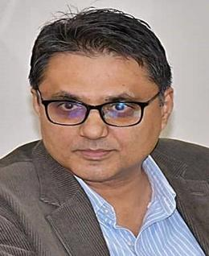
Ahsan Ali Mangi
Senior Associate | Public Policy, Governance, and Institutional Systems
Ahsan Ali Mangi brings over three decades of senior public sector leadership and policy experience across federal and provincial governments. He has held key positions including Federal Secretary, Additional Secretary, Commissioner, and head of major public institutions, with responsibilities spanning economic governance, trade diplomacy, education, social protection, disaster response, investment promotion, and regulatory reform.

His career reflects deep engagement with policy formulation, institutional oversight, intergovernmental coordination, and implementation of large-scale development and reform initiatives. Mr. Mangi has also represented Pakistan in multilateral settings and led complex negotiations and administrative systems at national and sub-national levels. At Hunar Saaz, he anchors work on governance reform, public sector systems, and institutional effectiveness, bringing strategic insight, administrative realism, and political economy awareness to advisory engagements.

Rana Iftikhar Raza

Senior Associate | Data Systems, EMIS, and Digital Governance
Rana Iftikhar Raza is a senior data systems and digital governance specialist with over thirty years of experience in Education Management Information Systems (EMIS), GIS-based planning, large-scale surveys, and public sector information systems. He has played a foundational role in the design, digitization, and institutionalization of EMIS and decision-support systems across multiple provinces, working closely with government counterparts and development partners. His expertise spans system architecture, spatial data integration, survey operations, third-party validations, and capacity building for data-driven planning and management. Mr. Raza has supported national and provincial reforms in education data systems and digital monitoring platforms. At Hunar Saaz, he leads work on data systems, digital transformation, and evidence infrastructure, strengthening institutional capacity for planning, monitoring, and informed decision-making.

Urooj Shafi

Associate | Public Sector Finance | Research & Trade
Urooj Shafi is a public sector finance and policy professional with 13+ years of experience spanning trade, market regulation, fair trade enforcement, monitoring & evaluation and sovereign financial analysis. She has produced sectoral research across engineering, minerals, agriculture, and textiles, analyzing tariff structures, comparative country policy, and macroeconomic indicators, and translating that work into briefs that reached senior policymakers directly. Trained in both law (LLB) and finance (MBA), and recognized as a U.S. State Department Professional Fellow, she brings to consulting engagements an uncommon triangulation of quantitative rigor, regulatory literacy, and disciplined research. At Hunar Saaz, she contributes with applied research on markets, trade, and public finance — producing the analysis and evidence base that informs institutional planning, policy design, and decision-making.

Domains and Thematic Expertise
Expertise organized around systems and outcomes.
Hunar Saaz works across interconnected domains within the social sector, reflecting the reality that policy effectiveness, programme performance, and institutional capacity are deeply interdependent. Rather than operating through isolated sectoral silos, our work is organized around thematic areas where policy intent, evidence generation, implementation systems, and institutional incentives converge.
Our thematic expertise has been shaped through long-term engagement with public sector institutions and development partners, particularly in contexts characterized by complexity, fragility, and capacity constraints. Across all domains, our focus remains on designing solutions that are analytically sound, context-aware, and operationally feasible.

Social Protection, Poverty Reduction, and Inclusion
Hunar Saaz has deep expertise in the design, implementation, and evaluation of social protection systems and poverty reduction programmes. Our work spans unconditional and conditional cash transfers, targeting systems, beneficiary registries, grievance redress mechanisms, and links between social assistance and human development outcomes.

We bring particular strength in evidence-based targeting, digital registries, and programme architecture that integrates poverty data with service delivery systems. Our experience supports governments in strengthening social protection as an adaptive instrument capable of responding to chronic poverty, shocks, displacement, and climate-related vulnerabilities while maintaining transparency, accountability, and fiscal realism.

Gender Equality, Women’s Empowerment, and Social Inclusion
Gender equality and social inclusion are core analytical lenses across Hunar Saaz’s work rather than standalone thematic add-ons. We have extensive experience supporting gender-responsive policy design, programme evaluation, and institutional frameworks aligned with international commitments such as CEDAW, BPfA, and the SDGs.

Our work in this domain emphasizes the translation of normative gender commitments into measurable outcomes through indicators, data systems, and institutional accountability mechanisms. We also engage on issues of gender-based violence, women’s economic participation, political inclusion, disability inclusion, and equity in service access particularly in fragile, rural, and marginalized contexts.

Monitoring, Evaluation, and Evidence for Decision-Making
Hunar Saaz has strong technical depth in monitoring, evaluation, and learning, with a focus on moving beyond compliance-driven reporting toward decision-useful evidence systems. Our expertise includes quasi-experimental and mixed-methods evaluations, theory-based evaluation, impact assessments, and adaptive learning frameworks.

We support institutions in designing M&E systems that are proportionate to capacity, aligned with programme objectives, and embedded within planning and implementation cycles. Our work emphasizes feedback loops, learning-oriented reviews, and the strategic use of data to inform policy choices, programme adjustments, and resource allocation.

Data Systems, Digital Transformation, and Registries
We bring significant expertise in large-scale data systems, digital surveys, registries, and management information systems supporting planning, targeting, and service delivery. This includes population-based surveys, poverty and beneficiary registries, EMIS, GIS-enabled systems, and real-time monitoring platforms.

Hunar Saaz supports institutions in strengthening data governance, system integration, data quality assurance, and institutional ownership of digital platforms. Our approach prioritizes usability, sustainability, and alignment with administrative processes, ensuring that digital investments translate into practical decision-making capability rather than standalone technology solutions.

Health, Nutrition, WASH, and Human Development
Hunar Saaz has substantial experience across health, nutrition, WASH, and broader human development programmes, particularly in fragile, disaster-affected, and underserved areas. Our work spans programme design, needs assessments, outcome evaluations, and systems strengthening for service delivery.

We engage with these sectors through an integrated lens, recognizing the interconnections between health, nutrition, water and sanitation, gender dynamics, and social protection. Our focus remains on strengthening delivery systems, community engagement, and institutional coordination rather than isolated infrastructure or awareness interventions.

Education, Skills, and Human Capital Development
Our expertise in education and skills development includes sector planning, EMIS, school censuses, education financing, programme monitoring, and institutional reform. We have worked across early childhood, basic education, secondary education, and skills development, supporting both policy formulation and implementation systems.

Hunar Saaz emphasizes data-driven planning, accountability, and institutional capacity in education systems, with particular attention to equity, access, and quality in marginalized and underserved regions.

Climate Resilience, Disaster Risk, and Fragility
Hunar Saaz brings experience in disaster risk management, post-crisis recovery, climate vulnerability analysis, and resilience-oriented programme design. Our work includes post-disaster needs assessments, recovery programme evaluations, and integration of risk-informed approaches into development planning.

We support institutions in designing programmes and systems that are resilient to shocks whether climatic, economic, or conflict-related by strengthening preparedness, adaptive capacity, and institutional coordination across sectors and levels of government.

Governance, Public Sector Reform, and Institutional Strengthening
Governance and institutional performance underpin all of Hunar Saaz’s thematic work. We engage with public sector institutions on policy coherence, intergovernmental coordination, regulatory reform, organizational design, and capacity strengthening.

Our approach to institutional strengthening is embedded and practice-based. Rather than standalone training or advisory outputs, we work alongside institutions to improve planning, implementation, monitoring, and review processes within existing systems supporting reforms that are realistic, politically aware, and sustainable over time.

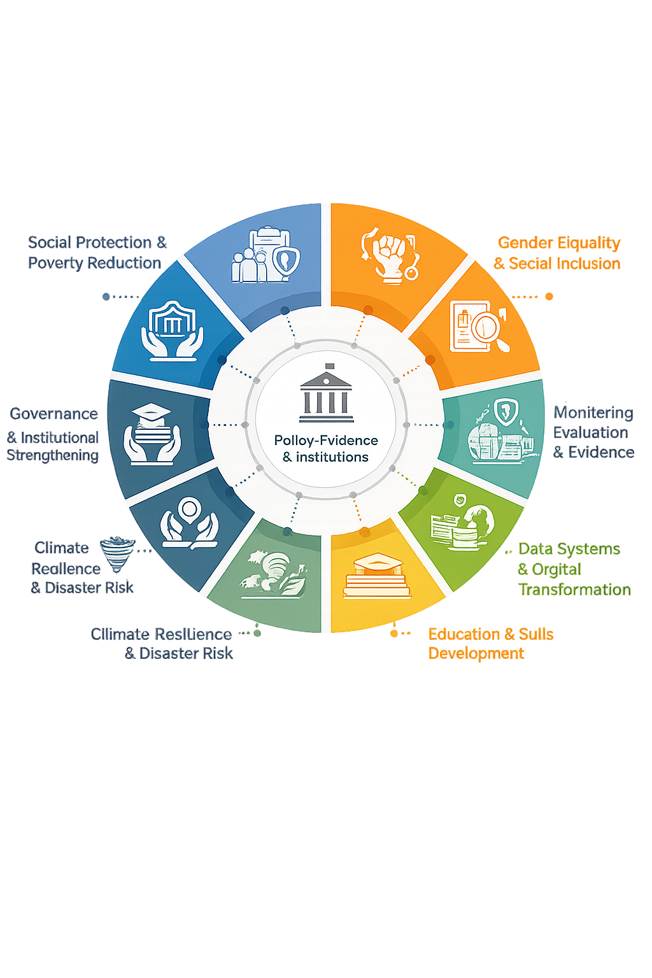

Geographic Experience & Exposure
Drawing on leadership experience across diverse governance and development contexts.
While Hunar Saaz is a newly established firm, its geographic experience is anchored in the extensive professional exposure of its founding leadership and senior associates. The team brings long-standing experience working across diverse geographic, administrative, and socio-political contexts within Pakistan, as well as selected international settings through prior institutional roles and advisory engagements.

Within Pakistan, Hunar Saaz’s leadership has worked across federal, provincial, and local governance systems, with direct experience spanning Punjab, Sindh, Khyber Pakhtunkhwa, Balochistan, Gilgit-Baltistan, and Azad Jammu & Kashmir. This includes engagement in urban, peri-urban, and remote rural contexts, as well as fragile, disaster-affected, and conflict-impacted regions.

Internationally, members of the leadership team have contributed to policy, research, and advisory assignments across South Asia, the Middle East, and Africa, working with multilateral organizations, development partners, and regional institutions. These experiences inform Hunar Saaz’s understanding of comparative policy approaches, institutional design, and implementation challenges across different governance environments.

This geographic exposure strengthens the firm’s ability to design context-sensitive solutions, adapt analytical approaches to local realities, and engage effectively with institutions operating under varied administrative and political conditions.

Selected Experience and Engagement Snapshots
The experiences below reflect selected leadership roles and engagements of Hunar Saaz’s founding partners prior to the establishment of the firm.

National Socio-Economic Registry and Digital Poverty Targeting (Pakistan)
Social Protection | Data Systems | Implementation
Led the operational design and nationwide implementation of Pakistan’s first end-to-end digital poverty census, covering over 35 million households across all provinces and regions. The work involved development of survey instruments, digital data architecture, field protocols, and real-time monitoring systems, laying the foundation for evidence-based targeting of social protection programmes and large-scale financial inclusion of women beneficiaries.

CEDAW and Beijing Platform for Action (BPfA+30) National Reporting
Gender Equality | Policy Reporting | Institutional Coordination
Provided national technical leadership for Pakistan’s reporting to the United Nations under CEDAW and BPfA+30, in partnership with UN Women and the Ministry of Human Rights. The engagement involved development of gender-responsive indicator frameworks, multistakeholder consultations across federal and provincial institutions, and synthesis of evidence to align national policy commitments with international gender and SDG obligations.

Digital Population and Housing Census (Pakistan)
Governance | Data Systems | National Operations
Served as technical advisor to the Pakistan Bureau of Statistics for the country’s first-ever digital Population and Housing Census. The assignment covered census design, operational planning, GIS-based mapping, logistics management, and centralized monitoring systems, supporting real-time decision-making and adaptive field management during nationwide rollout.

Post-Conflict Recovery and Cash Transfer Programming (Former FATA)
Fragility | Social Protection | Programme Design
Led the design and implementation of large-scale recovery and cash transfer programmes for conflict-affected and displaced populations across seven districts of former FATA. The work included development of programme appraisal documents, targeting methodologies, monitoring frameworks, and outcome studies covering health, nutrition, education, livelihoods, and shelter.

Trade Policy, Trade Diplomacy, and Institutional Reform (Pakistan)
Economic Governance | Policy Advisory | Public Institutions
Provided senior leadership in trade policy formulation, trade diplomacy, and institutional strengthening through roles within the Ministry of Commerce and the Trade Development Authority of Pakistan. Engagements included development of export strategies, impact assessments of trade agreements, international trade promotion initiatives, and advisory support on investment and commercial policy frameworks.

Education Systems Reform and EMIS Development
Education | Data Systems | Institutional Capacity
Led and supported the design, digitization, and institutionalization of Education Management Information Systems (EMIS) across multiple provinces. The work included school censuses, GIS-based planning tools, third-party validations, and capacity building for education managers, strengthening evidence-based planning and accountability in the education sector.

Disaster Risk Management and Post-Disaster Recovery
Climate & Disaster Risk | Governance | Service Delivery
Provided leadership in disaster risk reduction, emergency response, and post-disaster recovery across federal and provincial institutions. This included post-disaster needs assessments, recovery programme evaluations, and integration of risk-informed planning into development and service delivery systems in flood- and earthquake-affected regions.

Governance Reform and Public Sector Institutional Strengthening
Public Administration | Systems Reform | Political Economy
Held senior leadership roles across federal and provincial governments, including Secretary-level and Commissioner positions, overseeing policy formulation, institutional reform, intergovernmental coordination, and implementation oversight across social sectors. These roles involved navigating complex political economy environments and strengthening institutional performance and accountability mechanisms.

Applied Research, Evaluation, and Learning Across Social Sectors
Monitoring & Evaluation | Evidence | Learning
Led and contributed to a wide range of applied research, evaluations, and learning engagements across social protection, gender, health, nutrition, WASH, education, disability inclusion, and humanitarian response. The work emphasized mixed-methods approaches, decision-useful evidence, and translation of findings into policy and programme improvements.


Legal Status & Institutional Standing
Formal incorporation and institutional status
Hunar Saaz is a legally registered not-for-profit organization in Pakistan. It is registered under the Societies Registration Act, 1860, with its principal registration in Rawalpindi District, Punjab. The organization is also provisionally registered with the Punjab Charity Commission as a Category A entity, authorizing province-wide operations within Punjab.

Hunar Saaz operates under a formal governance structure, including a General Council and Management Body, ensuring institutional oversight, accountability, and compliance with applicable regulatory requirements. The organization maintains a commitment to transparency, ethical conduct, and responsible institutional engagement.

This legal and governance framework enables Hunar Saaz to work formally with government entities, development partners, multilateral organizations, and civil society actors.

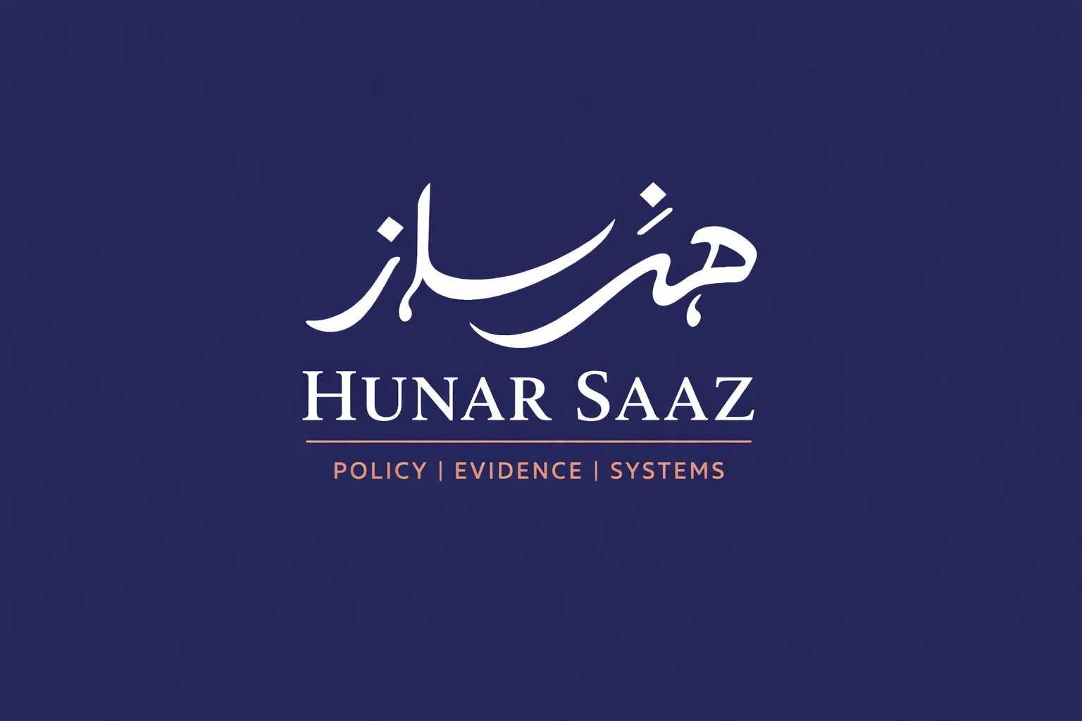
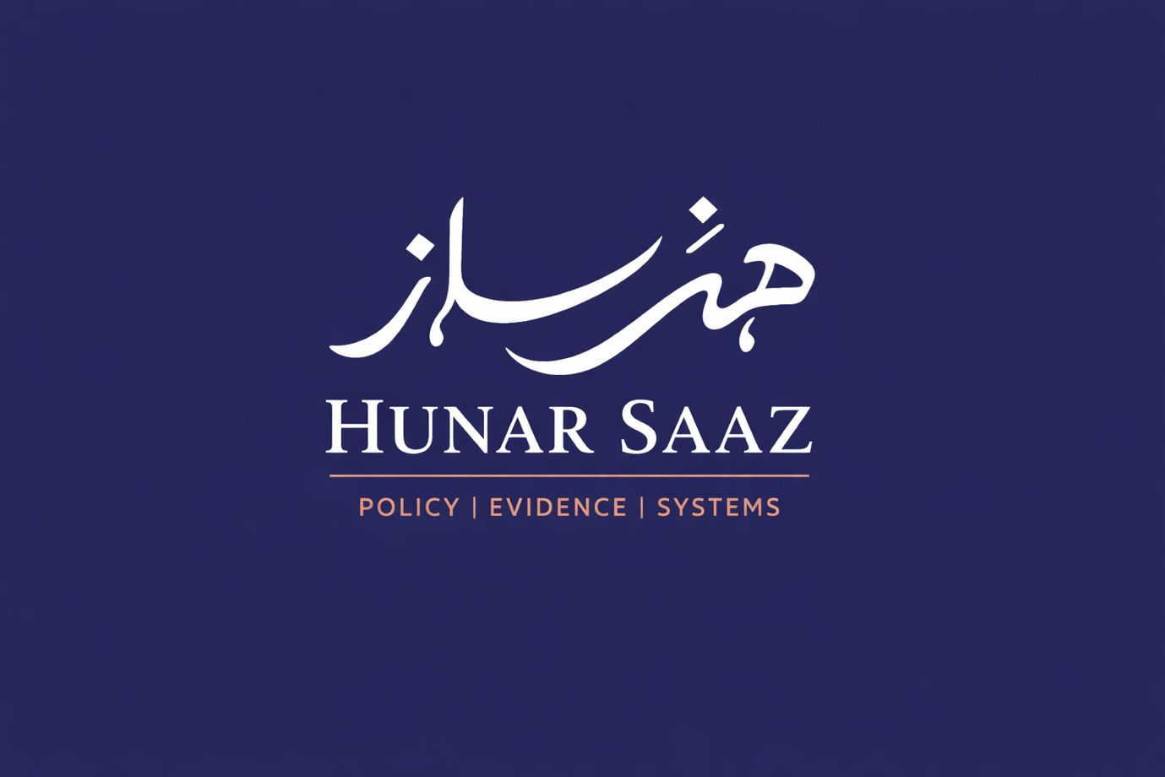


Formal incorporation and institutional status
Formal incorporation and institutional status

